Lab53:
Views:
I have created a view to join the Employee and Emp_Address tables to see employee details along with their address.
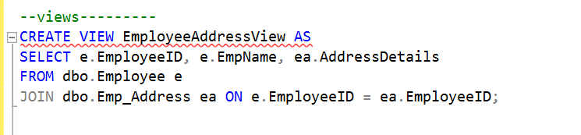
Here is view that is created in a folder structure:
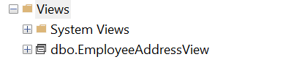

Create indexed view:
Created an indexed view to improve query performance.
Created a view named EmployeeSalaryView with schema binding. Schema binding ensures the underlying tables cannot be modified in a way that would affect the view. Select the fields from the table.
Create a unique clustered index on the EmployeeSalaryView

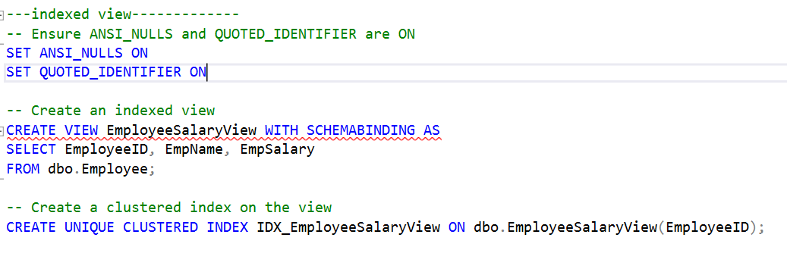
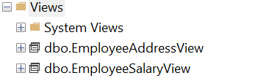

Modify view:
Modify the EmployeeAddressView to add the employee salary column here.
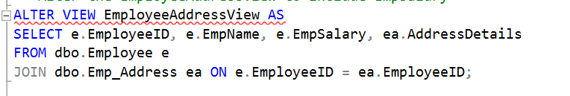
Steps:
- Altering the existing EmployeeAddressView to include the EmpSalary column.
- Select EmployeeID, EmpName, adding EmpSalary, AddressDetails from the Employee and Emp_Address table.

Modify Data Through a View:
Steps :
- Update the EmpName through the EmployeeAddressView
- Verify the update in the underlying Employee tableChanging the name of the employee with EmployeeID = 1.
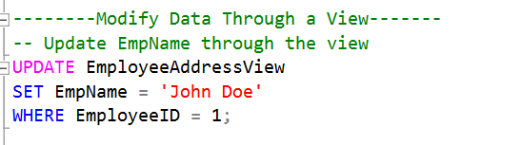
Output:
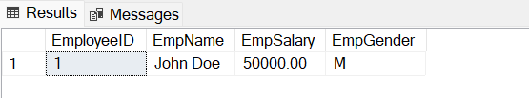

Delete an existing view:
Here I am deleting an existing view which is EmployeeAddressView by DROP command.

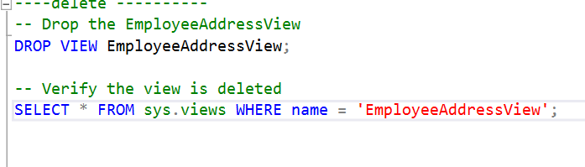
Here I can see that the view is deleted from the structure.
